My Name is Xiao Kuang. I was born in China and moved to the US when I was 5. I attended OSU in 2012 after graduating from Siuslaw High School in Florence, Oregon. After completing my bachelor’s in Environmental Engineering, I wanted to switch careers and I joined the OSU post-bacc CS program in the Spring of 2017.

My interests include Mechanics, computers, and gaming. What brought me over to wanting a career in computer science is that there is so much I could do with it. Technology is always growing and changing and I’m very curious to learn about network security, reverse-engineering, encryption. After graduation I hope to have more clear goals and to be passionate and enjoy what I’m doing. In five to ten years I hope to be overseeing a project I care for and have a passion for, and ideally be working for a company I respect and am proud to be working for or have my own company that I’m proud of leading.

Maybe mixing my previous degree with this one to find a job that involves programming or application of computer science to environmental engineering, or mixing my love of cars with computer science – designing and programming embedded systems for various car technologies. Cyber security also interests me – I hope I can learn many different topics and have opportunities to pursue the topics I enjoy as careers.

My outlook for the future is positive because I know there is something out there for me that I am going to absolutely love doing and getting paid for it.

Source code:

/*

* areaTriangle.c

*

* Created on: Jan 12, 2019

* Author: Xiao Kuang

*/

**#include** <stdio.h>

**#include** <math.h>

//formula for area of triangle

//A = sqrt ( s(s-a)(s-b)(s-c)),

//where s = (a+b+c)/2

**void** **areaTriangle**(**double** a, **double** b, **double** c){

**double** s = ((a + b + c)/2);

**printf**("%f ",**sqrt**(s*(s-a)*(s-b)*(s-c)));

}

**int** **main**() {

areaTriangle(3,4,5);

areaTriangle(5,5,6);

areaTriangle(5,5,8);

areaTriangle(13,4,15);

**return** 0;

}

Screenshot of output using IDE:

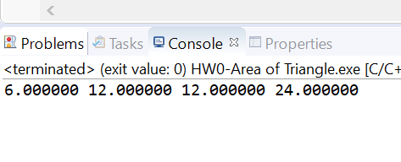

Screenshot of output using flip:

